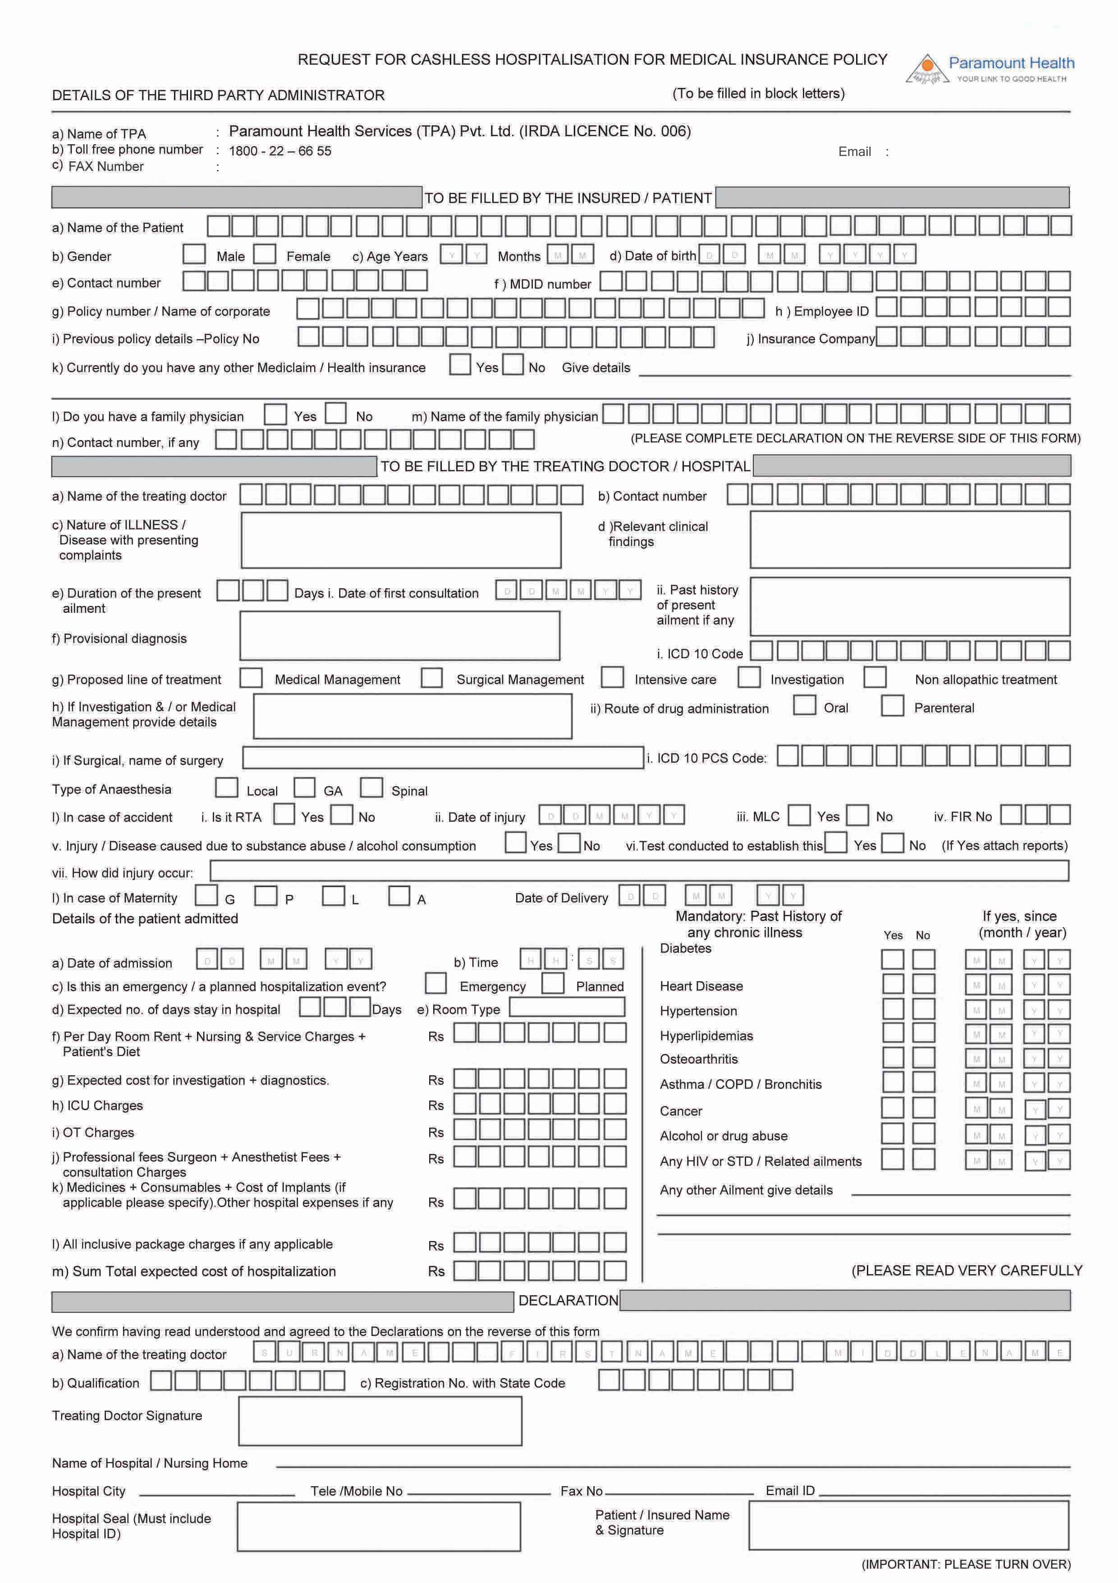
al.request@paramounttpa.com
022 - 66444781 I 66444782 I 66444783 I 66444754 I 66444755 I 66444709(Email id of patient to be added)
