# FAQs on SARS-CoV-2 Variant-Omicron

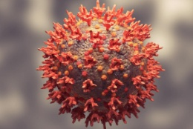

**What is Omicron and what makes it a variant of concern (VoC)?**

It is a new variant of SARS-CoV-2 that has recently been reported from South Africa on 24th November 2021 called as B.1.1.529 or Omicron (based on Greek alphabets like alpha, beta, delta etc). This variant has shown a very large number of mutations, especially more than 30 on the viral spike protein, which is the key target of the immune response.

Given the collection of mutations in Omicron, which earlier individually have been associated with increased infectivity and/or immune evasion, and the sudden rise in number of positive cases in South Africa, World Health Organization has declared Omicron as a Variant of Concern (VoC).

# Can the currently used diagnostics methods, detect Omicron?

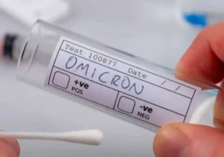The most accepted and commonly used method of diagnostic for SARS-CoV- 2 Variant is RT-PCR method. This method detects specific genes in the virus, such as Spike (S), Enveloped (E) and Nucleocapsid (N) etc to confirm the presence of virus. However, in case of Omicron, as the S gene is heavily mutated, some of the primers may lead to results indicating absence of the S gene (called as S gene drop out). This particular S gene drop out along with the detection of other viral genes could be used a diagnostic feature of Omicron. However, for final confirmation of the omicron variant genomic sequencing is required.

# How concerned should we be about the new VoC?

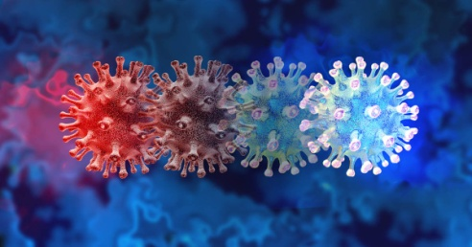WHO declares a variant as a VoC after assessment when there is increase in transmissibility or detrimental change in COVID-19 epidemiology; OR increase in virulence or change in clinical disease presentation; OR decrease in effectiveness of public health and social measures or available diagnostics, vaccines, therapeutics. (Source: WHO)

It is important to highlight that Omicron has been declared VoC based on the observed mutations, their predicted features of increased transmission and immune evasion, and preliminary evidence of detrimental change in COVID-19 epidemiology, such as increased re-infections. The definitive evidence for increased remission and immune evasion is awaited.

**What are the common symptoms observed in COVID-19 and its variants?**

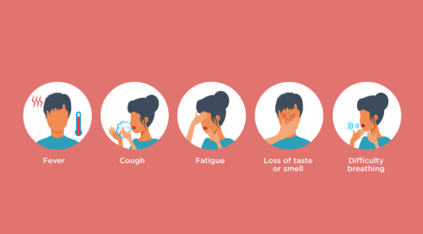Following are the common symptoms observed in COVID-19 which may differ from mild to severe-

* Fever or chills
* Cough
* Shortness of breath or difficulty breathing
* Fatigue
* Muscle or body aches
* Headache
* New loss of taste or smell
* Sore throat
* Congestion or runny nose
* Nausea or vomiting
* Diarrhea

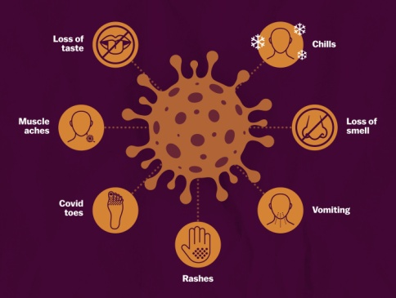

**When to seek emergency medical attention?**

* Trouble breathing
* Persistent pain or pressure in the chest
* New confusion
* Inability to wake or stay awake
* Pale, gray, or blue-colored skin, lips, or nail beds, depending on skin tone

# What precautions should we take?

# Hand and respiratory hygiene measures

# Omicron Variant: What is Omicron? What precautions should we take? Will there be a third wave? FAQsMedical mask to the suspected patients

# Cover nose and mouth during coughing with tissue/flexed elbow

# Perform hand hygiene after contact with respiratory secretions.

# Use of personal protective equipment (PPE)

# Prevention of needle-stick or sharps injury

# Safe waste management

# Environmental cleaning and sterilisation of patient-care equipment and linen:

# Thorough cleaning with water and detergent

# Applying hospital level disinfectants like sodium hypochlorite

# How can we prevent COVID-19?

# The best way to prevent illness is to avoid being exposed to the virus.

# Avoid close contact with people who are sick.

# Avoid touching your eyes, nose, and mouth with unwashed hands.

# Stay home when you are sick.

# Cover your cough or sneeze with a tissue, and throw it in the trash, or use the inside of your elbow.

# Clean and disinfect frequently touched objects and surfaces daily using a regular household

# Cleaning spray or wipe.

# Will there be a third wave?

Omicron cases are increasingly being reported from countries outside of South Africa and given its characteristics; it is likely to spread to more countries including India. However, the scale and magnitude of rise in cases and most importantly the severity of disease that will be caused is still not clear. Further, given the fast pace of vaccination in India and high exposure to delta variant as evidenced by high seropositivity, the severity of the disease is anticipated to be low. However, scientific evidence is still evolving.

# Will the existing vaccines work against Omicron?

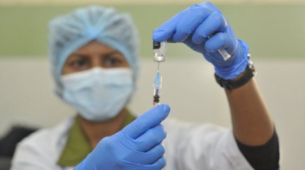While, there is no evidence to suggest that existing vaccines do not work on Omicron, some of the mutations reported on Spike gene may decrease the efficacy of existing vaccines. However, vaccine protection is also by antibodies as well as by cellular immunity, which is expected to be relatively better preserved. Hence vaccines are expected to still offer protection against severe disease and, vaccination with the available vaccines is crucial. If eligible, but not vaccinated, one should get vaccinated.

# How is India responding?

Indian government is monitoring the situation closely and is issuing suitable guidelines from time to time. Meanwhile, the scientific and medical community is geared up for developing and deploying diagnostics, carrying out genomic surveillance, generating evidence about viral and epidemiologic characteristics, and development of therapeutics.

# Why do variants occur?

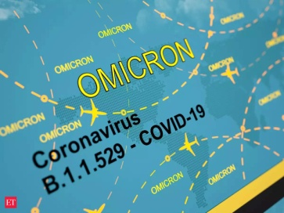Variants are normal part of evolution and as long as the virus is able to infect, replicate and transmit, they will continue to evolve. Further, not all variants are dangerous and most often than not, we don’t notice them. Only when they are more infectious, or can reinfect people etc they gain prominence. The most important step to avoid generation of variants is to reduce the number of infections.

***Source:***

***WHO and MoHFW, GoI and CDC***